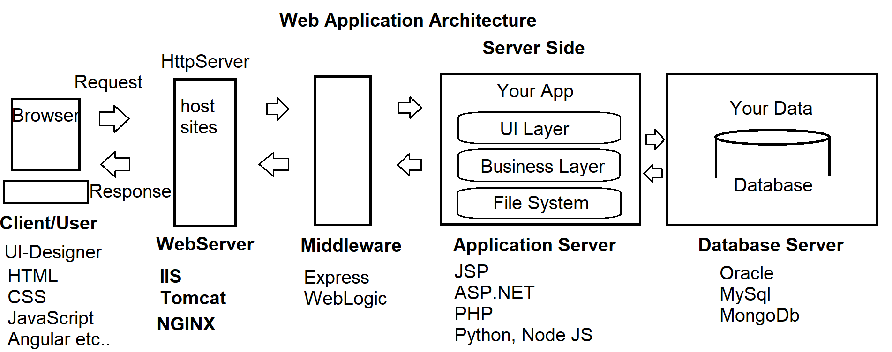

**What are the basic requirements to build an end-to-end Web Application?**

1. HTML
2. CSS
3. Client-Side Script

**JavaScript Language, JQuery Library, Angular Framework etc..**

1. Server-Side Script

**JSP, PHP, .NET, Python**

1. Middleware

**Express, Web Logic etc..**

1. Database

**Oracle, MySql, MongoDb etc..**

1. Desk Top Publishing Tools

**Photoshop, CorelDraw, Flash etc..**

1. IDE’s

**Visual Studio Code, WebStrom, Eclipse, Notepad++ etc..**

**Stack Developers**

* Java Stack
* .NET Stack
* PHP Stack
* Python Stack
* MEAN Stack

M - MongoDb Database

E - Express Middleware

A - Angular Client Side

N - Node JS Server Side

* MERN Stack

M - MongoDb Database

E - Express Middleware

R - React Client Side

N - Node JS Server Side

**What we learn in UI Technologies?**

1. HTML
2. CSS, Bootstrap
3. Client-Side Script

**JavaScript Language, JQuery Library, Angular Js, TypeScript**

1. Publishing Tools  
    **Photoshop, Flash**
2. IDE’s

**Visual Studio Code**

**We will learn how to publish live, integrate with server side and database**

**Web Terminology**

1. **Network  
   -** A group of computers connected with each other for sharing of information and resources.  
   - **ARPANET [**Advanced Research Project Agency Network**]** by US-DOD
2. **Types of Networks**- LAN [Local Area Network]  
   - MAN [Metro Politian Area Network]  
   - WAN [Wide Area Network]
3. **Internet**- It is a wide area network that connects computers all over the world.  
   - No restriction is access.  
   - Any user can access information from anywhere.
4. **Web  
   -** It is a portion of Internet with restricted access.  
   - Introduced in early 1990’s by **Tim Berners Lee** [Father of Web - HTML]  
   - Web standards are maintained by **W3C and WHATWG  
   - World Wide Web Consortium [w3c.org]  
   - Web Hyper Text Application Technology Work Group [whatwg.org]**
5. **Web Server**- It resembles both hardware and software.  
   - It satisfies the client request by sending and receiving data.  
   - It handles the client request, It process the request and sends response back.  
   - Popular Open Source Web Server Software:  
    **Tomcat, IIS [Internet Information Services], NGINX, Node.js, Lighttpd**- We use local web servers for hosting websites, and managing websites.  
   - We use live servers for production and go live. So that it can be accessed from any location.

**Setup Environment for Local Web Server**:

* Windows OS have a webserver called IIS
* Mac, Linux, OSX – download tomcat, IIS

**Windows IIS Web Server:  
-** Open windows control panel

**-** Administrative Tools  
- IIS [Internet Information Services Manager]  
  
**You can Add IIS to Windows**- Control Panel  
- Programs and Features  
- Turn Windows Features On or OFF  
- Select “Internet Information Services”  
  
**Test your Local Web Server [IIS]**- Open any browser  
- Type the URL : <http://localhost> or <http://127.0.0.1>

**6. Web Site**

**-** Web Site is a virtual directory of Web Server.

- Site [Location] on Web Server

- It provides access to the resources.

**Creating a new Web Site on Local Server:**

* Open your local web server “IIS” [Internet Information Services]  
  **Run 🡪 Inetmgr**
* Expand “Local Computer” [http://localhost]
* Expand “Sites” folder
* Right Click on “Default Website”
* Select the option “Add Virtual Directory”

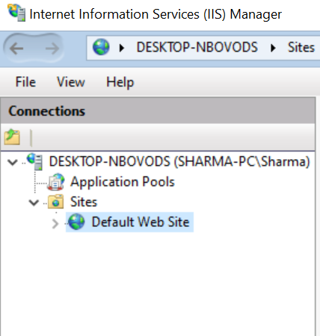

* Specify the following details for a new Website

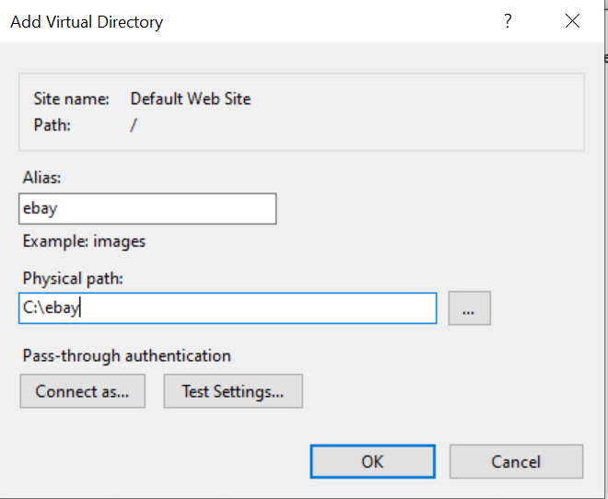

alias [Web site] Virtual Path : ebay

Physical path: : C:\ebay

* Open any browser and test your website

<http://localhost/ebay>

(or)

<http://127.0.0.1/ebay>

### Note: Initially it returns HTTP Error 403.14 - Forbidden

* You have to maintain resources for your website: Images, Documents etc.
* Go to your website Physical Path: **C:\ebay**
* Add folders and Files
  + Images
    - Banner1.jpg
    - Banner2.jpg
  + Docs
    - Cssdemo.pdf
* Your can request resource by using the virtual path  
  <http://localhost/ebay/Docs/cssdemo.pdf>

<http://localhost/ebay/Images/banner1.jpg>

* We have to provide an UI [User Interface] so that user can interact with the resources of our website.
* The UI is designed by using a **Hyper Text Document,** which is known as **“Web Page”.**

**Hyper - Greek - Beyond**

**Hyper Text - Beyond Text**

**7. Web Page**